Contents

[1 Introduction 1](#_Toc398746168)

[2 Method 1](#_Toc398746169)

[2.1 Clustering and the meanings 1](#_Toc398746170)

[2.1.1 2.2. Field trip survey 6](#_Toc398746171)

[2.2 2.3. Data processing 7](#_Toc398746172)

[3 Findings 7](#_Toc398746173)

[3.1 3.1. Fuelwood Demand Side 7](#_Toc398746174)

[3.2 3.2. Fuelwood Supply Side 19](#_Toc398746175)

[3.3 3.3. Fuelwood Supply – Demand Balance 19](#_Toc398746176)

[3.4 3.4. Value chain assessment in relationship to forest degradation and deforestation 19](#_Toc398746177)

[4 Recommendations 19](#_Toc398746178)

[4.1 4.1. Improved stoves 19](#_Toc398746179)

[4.2 4.2. Stability of electricity supply 19](#_Toc398746180)

[4.3 4.3. Promotion of LPG 19](#_Toc398746181)

[4.4 4.4. Training on natural forest management skills for households 19](#_Toc398746182)

[4.5 4.5. Creation of fuelwood source 19](#_Toc398746183)

FUELWOOD VALUE CHAIN ASSESSMENT IN THANH HOA AND NGHE AN

Draft final report

# Introduction

Fuelwood value chain assessment in relationship with forest degradation and deforestation.

# Method

## Clustering and the meanings

**Clustering method**

For fuelwood consumption survey, it is recommended to use stratified sampling rather than simple random. This is because we know that the studied population can be physically divided in to homogenous groups with respect to biomass consumption. The stratified sampling, therefore, will lead to greater accuracy in the estimates of fuelwood consumption patterns (smaller estimation errors than simple random sampling with the same sample size).

For this study, following variables are used for stratification.

**Table 1. Variables used for sample stratificaiton**

|  |  |  |
| --- | --- | --- |
| **Variable** | **Relation to biomass consumption** | **Data source** |
| - Population density 2010 | Basic demographic characteristic, reflect the demand size of biomass consumption. | MONRE 2010 - Commune level population density |
| - Mean elevation (ASTER DEM) | Geographic character of a population in relationship with biomass source and consumption. People living in higher altitude usually consume more fuel wood for heating | Global ASTER Digital elevation model, resolution 30 m. Computed as mean value for each commune |
| - Mean slope | Reflect the terrain condition and accessibility | Global ASTER Digital elevation model, resolution 30 m. Computed as mean value for each commune |
| Distance to road | Reflect the level of access to transportation | Distance to national road, inter-provincial road, inter-district road. Computed as mean value for each commune |
| Average annual temperature | Area with lower temperature would need more fuel wood for heating and cooking | Worldclim, global climate data at 1 km resolution. Computed as mean value for each commune |
| Min temp of coldest month | Area with lower temperature would need more fuel wood for heating and cooking | Worldclim, global climate data at 1 km resolution. Computed as mean value for each commune |
| Cover % of natural forest area | Reflect the source of fuel wood | MARD, National forest inventory 2010, available at provincial level |
| Cover % of plantation forest area | Reflect the source of fuel wood | MARD, National forest inventory 2010, available at provincial level |

All of the above information is extracted for each commune in Thanh Hoa and Nghe An. To classify all commune in the study area into homogenous group, the K-mean clustering method is employed. This procedure uses non-hierarchical clustering of observations according to MacQueen's algorithm[[1]](#footnote-1). The result of this process is 6 clusters of commune that are similar in term of biomass consumption (Fig1 and Fig 2). After some initial analysis of the clustering result, it was found that the cluster 1 is very small compare to other clusters. Cluster 1 represent communes and wards with very high population density that are mainly located in city and big towns. These area is not the target area of this study, therefore it was decided to exclude cluster 1 from the sampling scheme.

A brief interpretation of each cluster is as below:

|  |  |  |
| --- | --- | --- |
| Cluster | Interpretation | Forest to Delta Characteristics |
| Cluster 6 | Highest mountainous area, highest coverage of natural forest, less coverage of plantation forest, farthest to main truck roads, most depressed communes, lowest temparature of the medium coldest month temparature, lowest population density | Forest |
| Cluster 5 | High mountainous area, high coverage of natural forest, more plantation forest, closer to main truck roads, many depressed communes, less cold, higher population density |  |
| Cluster 4 | Low mountain and hills, less natural forest coverage, high plantation forest coverage, close to main truck roads, less depressed communes, less cold, population density increase significantly. |  |
| Cluster 3 | Major hills and flat land, almost no natural forest, most plantation forest coverage, very close major roads, almost no depressed communes, not cold, high population density |  |
| Cluster 2 | Delta land, no natural forest, few plantation forest, closest to major roads, warmest, highest population density | Delta |

Mapping of these clusters to communes of Thanh Hoa and Nghe An are as below:

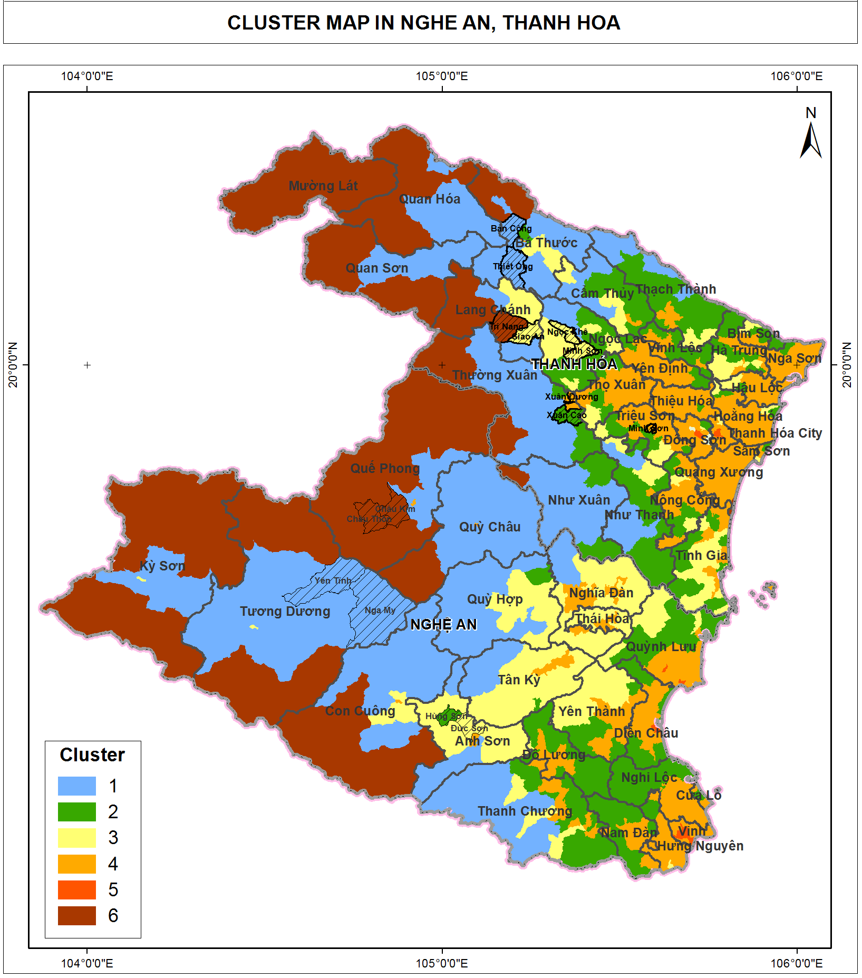

The selection of communes representing the clusters for researching are as below.

|  |  |  |  |  |
| --- | --- | --- | --- | --- |
| **STT** | **Province** | **District** | **Commune** | **Cluster\_New** |
| 1 | Thanh Hóa | Bá Thước | Thiết Ống | 5 |
| 2 | Thanh Hóa | Bá Thước | Bản Công | 5 |
| 3 | Thanh Hóa | Lang Chánh | Giao An | 4 |
| 4 | Thanh Hóa | Lang Chánh | Trí Năng | 6 |
| 5 | Thanh Hóa | Ngọc Lặc | Minh Sơn | 4 |
| 6 | Thanh Hóa | Ngọc Lặc | Ngọc Khê | 4 |
| 7 | Thanh Hóa | Thường Xuân | Xuân Dương | 2 |
| 8 | Thanh Hóa | Thường Xuân | Xuân Cao | 3 |
| 9 | Nghệ An | Anh Sơn | Hùng Sơn | 3 |
| 10 | Nghệ An | Anh Sơn | Đức Sơn | 4 |
| 11 | Nghệ An | Tương Dương | Yên Tĩnh | 5 |
| 12 | Nghệ An | Tương Dương | Nga My | 5 |
| 13 | Nghệ An | Quế Phong | Châu Kim | 6 |
| 14 | Nghệ An | Quế Phong | Châu Thôn | 6 |

## Field trip survey

***Household fuelwood consumption***

A questionnaire is designed for household interview. For each commune, 1 village is introduced by commune officer for households interview. At each village, at least 15 households introduced by the village head participated in the interview.

Commune officers (including people’s committee’s representative and/or forest rangers) were interviewed to find out the trend of household fuelwood consumption in the last and coming years.

2 restaurants and 1 primary school were visited for further understanding of residential demand for fuelwood.

***Local industrial consumption***

7 local industrial plants including 4 in Thanh Hoa and 3 in Nghe An were visited for interview and observation for fuelwood demand.

***Wood middlemen investigation***

2 middlemen, 1 on Thanh Hoa and 1 in Nghe An were visited. In-depth interviews were conducted with the middlemen to further understanding commercial demand for fuelwood and actors of fuelwood value chain.

## Data processing

***Household fuelwood consumption***

*First step,* the communes which use significant residues (rice residues, acacia barks) are separated for further analysis.

*Second step,* all households rising pigs or using energy for supplementary jobs are separated. The rest of households (energy only for people cooking and heating) are calculating for the average fuelwood consumption per person per month, by commune, and by cluster.

The result will be:

* Wood consumption per person per month for cooking with no alternative energy
* Wood consumption per person per month at households with electric rice cooker
* Wood consumption per pax per month at households with rice cooker and gas cooker
* Wood consumption per pax per month for heating in winter, ratio of heating

*Third step,* in-depth interview with 2 households that raise 8-10 pigs per year to find out the amount of wood consumption to raise a pig for 5 months.

***Qualitative analysis for industrial fuelwood demand***

The data collected are analyzed to find out the trend of fuelwood demand in the future of the local industrial sector. The data are also for analyse of fuelwood value chain.

***Qualitative analysis for wood middleman investigation***

The data collected are analyzed to understand the commercial fuelwood demand, an estimation of quantity of commercial fuelwood, actors in the fuelwood value chain.

This also to give a comparision between residential and commercial fuelwood consumption and to point out which actor is a bigger threat to forest degradation and deforestration.

### Fuelwood value chain assessment

Mapping of actors

Calculating value of activities

# Findings

## Fuelwood residential consumption

***Consumption of residue as an alternative for fuelwood***

The Table 1 below show that only Xuan Duong commune of Thuong Xuan district are using residues as the major biomass ernergy. About 80% of total biomass consumption at Xuan Duong are from corn cobs and acarcia bark.

***Table 1. Utilization of residue as an alternative for fuelwood***

|  |  |  |  |  |  |
| --- | --- | --- | --- | --- | --- |
| **STT** | **Province** | **District** | **Commune** | **Cluster ID** | **% residue of total biomass consumption** |
| 1 | TH | Bá Thước | Thiết Ống | 5 | 0 |
| 2 | TH | Bá Thước | Bản Công | 5 | 0 |
| 3 | TH | Lang Chánh | Giao An | 4 | 0 |
| 4 | TH | Lang Chánh | Trí Năng | 6 | 0 |
| 5 | TH | Ngọc Lặc | Minh Sơn | 4 | 0 |
| 6 | TH | Ngọc Lặc | Ngọc Khê | 4 | 0 |
| 7 | TH | Thường Xuân | Xuân Dương | 2 | 80 |
| 8 | TH | Thường Xuân | Xuân Cao | 3 | 0 |
| 9 | NA | Anh Sơn | Hùng Sơn | 3 | 0 |
| 10 | NA | Anh Sơn | Đức Sơn | 4 | 0 |
| 11 | NA | Tương Dương | Yên Tĩnh | 5 | 0 |
| 12 | NA | Tương Dương | Nga My | 5 | 0 |
| 13 | NA | Quế Phong | Châu Kim | 6 | 0 |
| 14 | NA | Quế Phong | Châu Thôn | 6 | 0 |

Xuan Duong belong to cluster 2, which is most close to delta and farthest to forest. Xuan Duong commune does not have any natural forest. Xuan Duong has only 6.66 hectare of plantation forest, of which most are acarcia. The population of Xuan Duong commune is 5,069 person. This means the average plantation area per person of Xuan Xuong is 0.0013 hectare per person. This number is very low, compared to the average of 0.03 hectare per person of Thanh Hoa. However, Xuan Duong people still utilize corn cob and acarcia bark that supply for 80% of biomass energy demand.

Below is a picture of biomass energy in Xuan Duong commune.

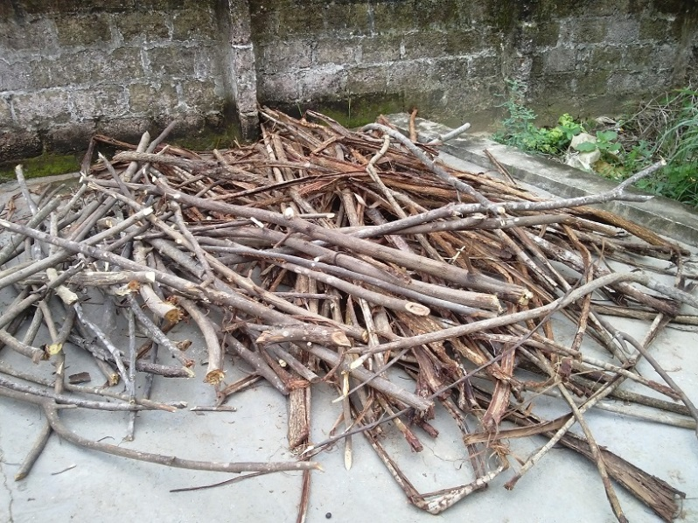

*Acarcia bark and cành xoan from home garden*

It should also noted that 100% households of Xuan Duong has electric rice cooker, and about 40% households has LPG cooker. However this is not a spcecial high rate compared to the rest 13 communes surveyed. This number will be reflected in the Table 2 below.

***Consumtion of fuelwood without residue***

***Table 2. Residential fuelwood consumption, excluding households that raise pigs and have supplement jobs, excluding Xuan Duong***

|  |  |  |  |  |  |  |  |  |  |  |
| --- | --- | --- | --- | --- | --- | --- | --- | --- | --- | --- |
| **STT** | **Province** | **District** | **Commune** | **Cluster ID** | **% householdss with electric rice cooker** | **% households with LPG cooker** | **% household consuming fuelwood** | **Kg of fuelwood per person per month** | **% small branch of wood and wood size <15cm** | **% of wood size >= 15cm** |
| **(1)** | **(2)** | **(3)** | **(4)** | **(5)** | **(6)** | **(7)** | **(8)** | **(9)** | **(10)** | **(11)** |
| 1 | TH | Bá Thước | Thiết Ống | 5 | 100 | 40 | 95 | 18.00 | 90 | 10 |
| 2 | TH | Bá Thước | Bản Công | 5 | 100 | 20 | 100 | 46.1 | 90 | 10 |
| 3 | TH | Lang Chánh | Giao An | 4 | 70 | 30 | 100 | 45.18 | 90 | 10 |
| 4 | TH | Lang Chánh | Trí Năng | 6 | 95 | 30 | 100 | 49.38 | 90 | 10 |
| 5 | TH | Ngọc Lặc | Minh Sơn | 4 | 100 | 40 | 100 | 60 | 90 | 10 |
| 6 | TH | Ngọc Lặc | Ngọc Khê | 4 | 90 | 40 | 100 | 28.75 | 90 | 10 |
| 8 | TH | Thường Xuân | Xuân Cao | 3 | 80 | 40 | 100 | 28 | 90 | 10 |
| 9 | NA | Anh Sơn | Hùng Sơn | 3 | 90 | 70 | 100 | 14.4 | 90 | 10 |
| 10 | NA | Anh Sơn | Đức Sơn | 4 | 100 | 45 | 100 | 28.33 | 90 | 10 |
| 11 | NA | Tương Dương | Yên Tĩnh | 5 | 5 | 2 | 100 | 66.96 | 90 | 10 |
| 12 | NA | Tương Dương | Nga My | 5 | 50 | 25 | 100 | 68.63 | 90 | 10 |
| 13 | NA | Quế Phong | Châu Kim | 6 | 70 | 13 | 100 | 36.32 | 90 | 10 |
| 14 | NA | Quế Phong | Châu Thôn | 6 | 40 | 5 | 100 | - | 90 | 10 |

It is noted that in the above table, data of column (6), (7), and (8) are collected from commune officers, while data for column (9) is collected from household survey. For the household survey, the rates of household that have electric rice cooker and LPG cooker might be different. Column (10) and (11) is from the household survey, from the estimation of the investigator.

Estimation of wood consumption by commune is as below:

***Table 3. Estimation of wood consumption by commune***

|  |  |  |  |  |  |  |  |
| --- | --- | --- | --- | --- | --- | --- | --- |
| **STT** | **Province** | **District** | **Commune** | **Cluster ID** | **Population** | **Kg of fuelwood per person per month** | **Estimation of wood consumption (kg/ month)** |
| **(1)** | **(2)** | **(3)** | **(4)** | **(5)** |  |  |  |
| 1 | TH | Bá Thước | Thiết Ống | 5 | 8283 | 18.00 | 149,094 |
| 2 | TH | Bá Thước | Bản Công | 5 | 6407 | 46.1 | 295,363 |
| 3 | TH | Lang Chánh | Giao An | 4 | 2461 | 45.18 | 111,188 |
| 4 | TH | Lang Chánh | Trí Năng | 6 | 2209 | 49.38 | 109,080 |
| 5 | TH | Ngọc Lặc | Minh Sơn | 4 | 8886 | 60 | 533,160 |
| 6 | TH | Ngọc Lặc | Ngọc Khê | 4 | 10772 | 28.75 | 309,695 |
| 8 | TH | Thường Xuân | Xuân Cao | 3 | 5551 | 28 | 155,428 |
| 9 | NA | Anh Sơn | Hùng Sơn | 3 | 3753 | 14.4 | 54,043 |
| 10 | NA | Anh Sơn | Đức Sơn | 4 | 8594 | 28.33 | 243,468 |
| 11 | NA | Tương Dương | Yên Tĩnh | 5 | 3917 | 66.96 | 262,282 |
| 12 | NA | Tương Dương | Nga My | 5 | 4372 | 68.63 | 300,050 |
| 13 | NA | Quế Phong | Châu Kim | 6 | 3938 | 36.32 | 143,028 |
| 14 | NA | Quế Phong | Châu Thôn | 6 | 3442 | - | - |

Estimation of wood consumption by cluster is as below:

***Table 4: Estimation of wood consumption per person by cluster***

|  |  |
| --- | --- |
| Cluster | Wood consumption per person per month (kg/ person/ month) |
| Cluster 6 | 41 |
| Cluster 5 | 43.8 |
| Cluster 4 | 39 |
| Cluster 3 | 22.51 |
| Cluster 2 | - |

While there is not a significant difference in fuelwood consumption for residential demand for cluster 4, 5, and 6, there is a more clear difference in fuelwood consumption for residential demand for cluster 3, where households have more access to urbanization and use of LPG, and less access to wood.

***Ratio by fuelwood size consumed by household***

The ratio of fuelwood size consumed by households is reflected in table 2 above. Only 10-20% of fuelwood consumed by households is of the size 15 cm and above in diameter. While most of fuelwood (80-90%) consumed has the size less than 15 cm. It is because the residents often collect wood by a machete of a size of 40cm. For this size of tool, the most suitable size of wood would be less than 20cm in diameter. They could mix wood size from 5 cm - 15 cm with small branches for a good fire for cooking.

Below are some pictures that represent the popular size for household cooking.

|  |  |
| --- | --- |
| E:\GFD\02 Ongoing projects\0193 SNV fuelwood baseline\Implementation\Field Trip\Anh\Anh report\CAM02691.jpg | E:\GFD\02 Ongoing projects\0193 SNV fuelwood baseline\Implementation\Field Trip\Anh\Anh report\CAM02661.jpg |
| E:\GFD\02 Ongoing projects\0193 SNV fuelwood baseline\Implementation\Field Trip\Anh\Anh report\CAM02680.jpg | E:\GFD\02 Ongoing projects\0193 SNV fuelwood baseline\Implementation\Field Trip\Anh\Anh report\CAM02717.jpg |

In winter for heating purposes, they would need to cut wood of bigger size so that they can maintain a smoldering fire which can last longer during the day. That explains the demand for 10% of wood size from 15 cm and above.

***Source of fuelwood***

There are 3 types of plantation forest in the area of survey: bamboo, acarcia, and gỗ lát. In Ba Thuoc and Lang Chanh and part of Ngoc Lac district of Thanh Hoa province, most plantation forest are bamboo. In the 3 districts of Nghe An of survey, acarcia is planted more as a source for paper material export.

For the households that have bamboo plantation forest, they utilize all bamboo roots and tops for cooking. Beside that, there is not any household that use acarcia wood for cooking. The reason that they don’t use acarcia wood for cooking is that it creates a lot of smoke that discomforts and may cause health issues.

About 20% of the fuelwood comes from home plantation. The rest of fuelwood of about 80% are natural wood, which either comes form natural forests tái sinh or cutting natural tree on the land of plantation forests. The natural wood provide better quality of wood, hence better quality of fire, lasting longer, more energy, and save time for the cookers. They can leave the wood in the stove for firing for long time, then at the same time working on other house works.

There is only one restaurant in the survey that use acarcia wood for cooking. See picture below:

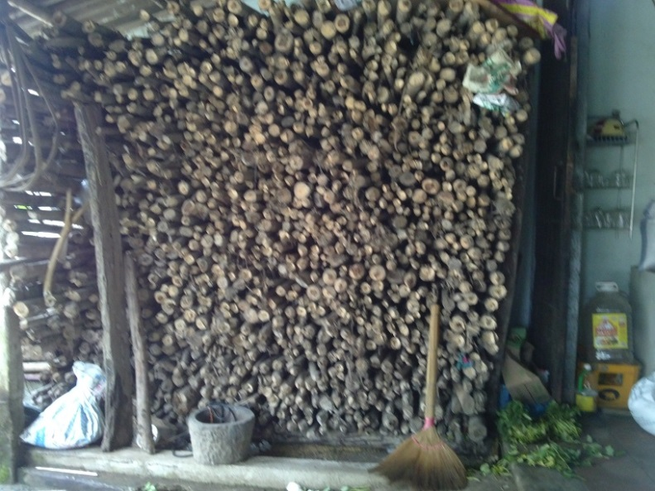

*Acacia wood at a restaurant in Lang Chanh town*

***Fuelwood for heating***

Bigger size of fuelwood (>20cm) are preferred by the residents for heating purpose. It is because bigger size of wood will give longer lasting fire. However, the trend is that less fuelwood for heating is demanded because people have more warm clothes and consolidate houses which help to keep warm.

Estimation for fuelwood heating demand is of the same amount for cooking for the 3 months of winter. That means in the winter, the demand for fuelwood might increase significantly to 100%.

***Fuelwood for pig raising***

It is estimated that in the higher land (Ba Thuoc, Lang Chanh, Que Phong, Tuong Duong) where pig only eat cooked feed, it needs about 200kg of wood for a pig raising for about 5 months. This is a very significant consumption for the households that raise more than 10 pigs per year.

In lower land in Hung Son and Duc Son of Anh Son district, half of pig feed is cooked by fuelwood and the other half is from prepared animal feed which does not require cooking. Therefore the consumption of wood per pig head at the lower land is much less than that of higher land.

***Trend for fuelwood consumption for residential demand***

As economic conditions are gradually improved, the households tend to buy electric rice cooker to save time for cooking while the cost for electricity is affordation for most households (estimated at 30,000 VND per month for rice cooking). For the household that have better imcome and easier access to LPG suppliers, they tend to use more LPG for cooking (cost for LPG differ from 70,000 VND to 150,000 VND per month).

Therefore the demand for fuelwood for cooking will reduce slowly. However, the residents will remain using fuelwood for at least next few years, as it is of long-time tradition, and it is a source of free energy available.

***Improved stoves***

For households that consumed fuelwood only for cooking, the residents tend not to be interested in improved stoves. They think that there are plenty of wood and so saving wood is not much helpful in their daily activities.

However for the households that consumped fuelwood for pig feed cooking and supplement jobs at a larger scale, people are more interestd in the improved stoves.

***Gender issue in fuelwood collection and cooking***

In the households that have buffelos, fuelwood collection is assigned to the persons who is in charge of buffelos feeding in the pastures. More men are assigned to feed buffelos, hence to collect wood than women.

Women are in charge of taking care of home, children. Therefoe more women are assigned to fuelwood used than man. But this trend is not very obvious since in more than half of the household surveyed, it is that both the men and women are involved with cooking.

## Local industrial consumption

***Distance of fuelwood consumption for local industrial***

The fuelwood are transported within a distance of 50km from the collection site to the industrial plants. If the wood are transported from further of that distance, the cost for transportation will increase which make the selling price increase.

Therefore the industrial plants that consume fuelwood are those which are located close to the forest. (In this case it is natural forest because wood from natural forest are cheaper than wood from plantation forest. This will be further explained in the next section). Within this distance, the price of wood per calorific value is cheaper than that of coal. Therefore a paper mill plant located in Lang Chanh buy fuelwood from Lang Chanh district, while a MDF plant located in Nhu Xuan and at the boundery between Thanh Hoa and Nghe An buy fuelwood from Quy Hop district. A tea plant in Thanh Chuong district purchase wood transported from Ha Tinh province and Laos.

Farther than than that distance, industrial plants prefer to use coal and dust coal because the price of coal is more competitive in terms of calorific value. Therefore, a paper mill in Lam Son of Thanh Hoa and a paper mill in Hung Son of Nghe An are using coal for their boilers. They have tried to use fuelwood before but the cost is higher. So they choose to use coal and dust coal for their boilers.

***Price of fuelwood selling to local industrial plants***

The popular price of fuelwood selling to local industrial plants is from 600,000 VND to 680,000 VND per ton. It is not possible to identify the specific species of wood, so it is assumed that the total average calorific value of wood (at moisture of 0%) is 4,000 kcal per kg and the actual moisture is at about 35% (wood partly dry since logged). Then the price per energy value is 0.2 VND per kcal.

This is to be compared with coal price sold at lower land of Thanh Hoa and Nghe An. The price for coal is about 3,800 VND per kg for calorific value of 7,500 kcal/ kg, and dust coal is about 1,950 VND per kg for calorific value of 5,600 kcal/ kg. These are 0.5 VND per kcal and 0.35 VND per kcal equivalent.

Therefore the price of fuelwood in the area close to forest is much cheaper than the price of coal.

## Commercial activities of middlemen

***Distance of commercial wood***

Commercial fuelwood are transported within a distance of 50km. Within this distance, the transporters are very familiar with roads, and traffic police routines. They can avoid police check on transport weight, and transportation legal document. Wood trucks are often over weighted: for example for a truck of 20 ton of load permit, it often carries 42 – 43 tons of wood. Transportation documents are often insufficient: for example it lacks of exploitation permits or commune verification.

Further than 50km, there is high potentiality of police punishment due to law violation including overweight transportation, lacking of proper transportation documents. The punishment rate is very high, up to 15.000.000 VND per truck of 42 tons of wood (for a truck of 20 tons of load permit), and the truck could be kept by the police for 30 days. It would lead to an occurrence of costs of 375.000 VND of ton of wood, not to mention the vehicle keeping cost by the police. While the selling price is about 1.000.000 VND per ton of wood, the occurrence of costs of 375.000 VND/tons is very much significant that the middlemen do not choose to take the risk.

***Source of commercial wood are natural wood***

100% of fuelwood for commercial activities are natural wood. The reason is that the price of planted wood (acarcia) to sell as paper material is higher than natural wood. The price of acacia at collection site at district (without transportation cost) is 750.000 – 850.000 VND per fresh ton after peeling the bark (right after cutting down, most of moisture is still contained), while the price of natural wood at collection site at district is from 500.000 to 550.000 VND per ton for partly dry wood (2-3 weeks after cutting down).

Below are the pictures of commercial fuelwood.

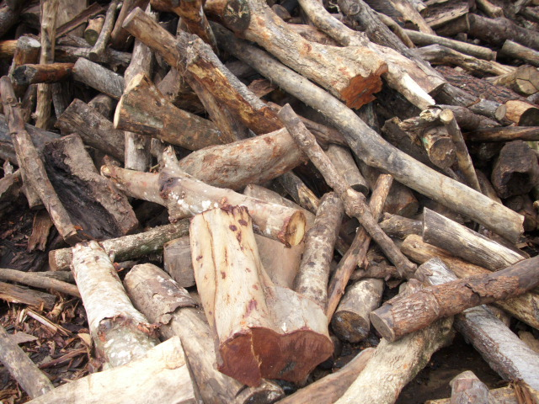



***A significant natural wood is exploited from forest conversion***

The source of these natural wood are either from natural forest or converted plantation forest.

It is found out that in Quy Hop district of Nghe An province, there was a significant area of natural forest that has been converted to plantation forest for acacia plantation. For example, from 2010 – 2013, xxx hectares of natural forest in Nghe An has been converted to plantation forest (Source: xxx). For these forest conversion, exploitation of natural wood is allowed by the laws. Therefore a big amount of natural wood are exploited legally on a wide area. The below picture shows the natural wood logged from converted forest.

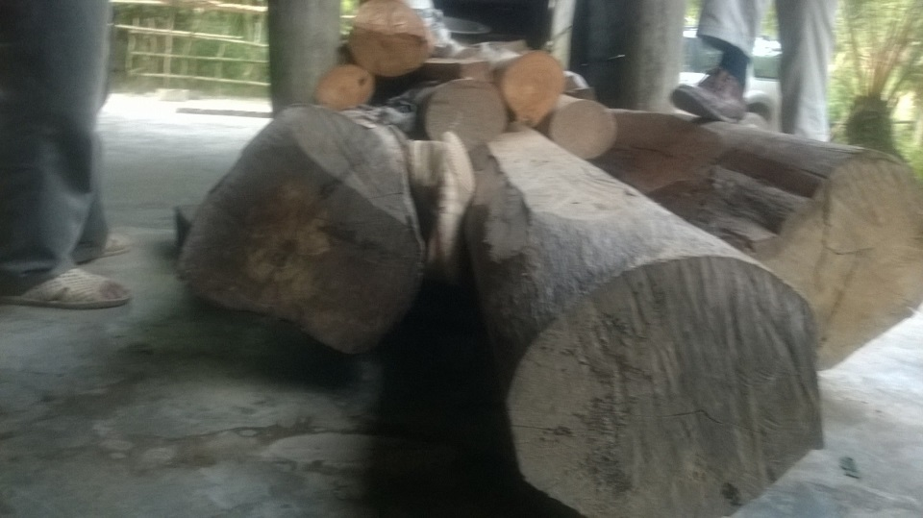

***Size of commercial wood***

The commercial fuelwood supplied to the plant by the middleman in Quy Hop district include about 10% of wood of diameter size of 25-30cm, 60 to 70% of wood of size 15-25 cm, the rest of 20 to 30% of wood of size 10-15cm. These are the sizes and ratio which is suitable for transportation and combustion at industrial boilers.

## Discussion of total fuelwood consumption

Within the scope of this research, it is not allowed to conduct a full primary survey of local industrial fuelwood consumption. Instead, only selected plants were investigated including:

* In Thanh Hoa: 1 paper mill, 1 wood chipper, 1 MDF plant
* In Nghe An: 2 tea plants, 2 paper mill

A full picture of mixed fuelwood consumption including residential and commercial consumption is very much depending on specific residential – industrial – commercial consumption models. Therefore specific sites are selected for consumption analysis case by case.

Two districts, one for each province have been identified as of most busy fuelwood trading activities. For Thanh Hoa it is Lang Chanh district. For Nghe An it is Quy Hop district (though Quy Hop is not of the survey of household). These two districts have cluster 4, which has the characteristics of lower hills and mountain, less natural forest, more plantation forest, easier access to main roads (which means more commercialized), medium population density. In other words, it means that these two districts are in the middle between forest (of cluster 6 and 5: higher mountain, more natural forest, less plantation forest, lower population density) and delta (of cluster 3 and 2: low land, no forest, highest population density). Since these two districts are in the middle of forest (as source of fuelwood) and delta (as demand side of fuelwood for industrial plants), naturally it has busy fuelwood trading activities.

**Discussion of total fuelwood consumption of Lang Chanh district, Thanh Hoa**

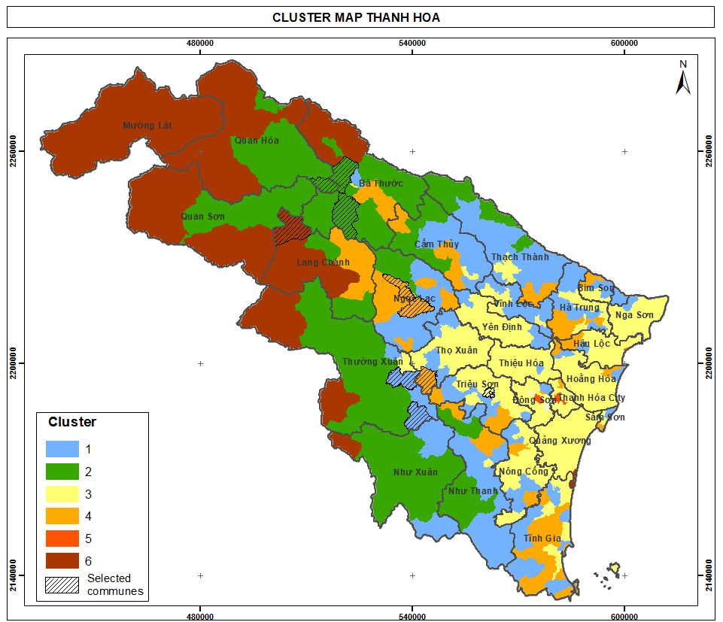

*Cluster map of Thanh Hoa province*

***Residential wood consumption***

Lang Chanh is a district of Thanh Hoa province, which has a population of 43,913 person. Natural area is of 5,846 km2. Population density of 7.51 person per square kilometer. This density is low compared to average density of Thanh Hoa province of 32.1 person per square kilometer.

Lang Chanh has average natural forest per capita of 0.67 hectare/ person and plantation forest per capita of 0.28 hectare/ person (compared to 0.11 and 0.03 of Thanh Hoa province).

|  |  |  |  |  |  |  |  |
| --- | --- | --- | --- | --- | --- | --- | --- |
|  | Population | Area (ha) | Density person/km2 | Natural forest area (ha) | Plantation forest area (ha) | Area of natural forest per pax | Area of plantation forest per pax |
| Thanh Hoa | 3,557,482 | 1,108,239 | 32.10 | 381,220 | 110,968 | 0.11 | 0.03 |
| Lang Chanh  District | 43,913 | 58,463 | 7.51 | 29,347 | 12,151 | 0.67 | 0.28 |

Lang Chanh district include 3 cluster:

|  |  |  |  |  |  |
| --- | --- | --- | --- | --- | --- |
| Item | Unit | Cluster 6 of Lang Chanh | Cluster 5 of Lang Chanh | Cluster 4 of Lang Chanh | Lang Chanh district |
| Population | Person | 15,666 | 7,423 | 20,824 | 43,913 |
| Wood consumption per month by person by cluster | kg | 41 | 43.8 | 39 |  |
| Wood consumption per month by person by cluster | kg | 492 | 525.6 | 468 |  |
| Total wood consumption | Ton | 7,708 | 3,902 | 9,746 | 21,355 |

Based on this assumption, total fuelwood consumption of Lang Chanh is about 21,000 tons of wood per year. While this number is much larger than the total commercial fuelwood demand (to be mentioned below), it needs to note that only 10% of this amount is of size 15 cm and above. The rest of it 90% are of size less than 15 cm. That means about 2,100 tons of wood size 15 cm and above are consummed by residential demand of Lang Chanh district.

***Commercial wood consumption***

It is found out that there are 3 biggest wood middlemen in Lang Chanh. Each middleman works in several communes to buy wood exploited from natural forest. They buy wood from the villagers and sell to industrial plants within the distance of 50km. Based on actual demand of the plants, they will order the villagers to log wood from the forest. The total daily exploited amount of all the three middlemen in Lang Chanh is about 14-15 tons per day, for about 300 days a year.

As this fuelwood will be transported and to serve the boilers or furnace of industrial plants, the size of the wood is requested to be bigger (for transportation purpose) and the quality of wood required is higher than the quality of wood consumed by households. According to one middleman, the ratio of wood size of these fuelwood is that 20-30% of size 10-15cm, 50-60% of size 15-25cm, and 10% of size 30 cm and above. Total ratio of wood size from 15 cm and above is therefore about 70 %.

It is estimated that the demand for fuelwood for commercial purpose at Lang Chang is 1,350 tons of size 10-15cm and 3,150 tons of size 15 cm and above annually. Compared that with 21,000 of size 15 cm and above consumed by households (10% of total consumption), it is found out that the commercial demand is contributing to 60% of valued natural wood demand in total consumption, while residential demand is contributing to approx. 40% of that comes from the demand of heating of residents.

***Trend in fuelwood consumption in Lang Chanh***

While it is seen that the trend for fuelwood consumption by households is decreasing because of increasing electric rice cooking and LPG cooker, there is not a sign that the demand for industrual wood in the region will decrease. In fact, the industrial plants surveyed are operating at 60-70% of installed capacity due to economic crisis. When the existing plants are operate in full capacity, it may create futher pressures on fuelwood demand.

**Discussion of fuelwood in Nam Son commune, Quy Hop district, Nghe An**

Quy Hop is a district located in the middle the main roads from higher mountainous area to the low land of Nghe An province. Wood trading activities are crowded in Quy Hop.

***Table xx. Demography of Nghe An province, Quy Hop district, Nam Son commune***

|  |  |  |  |  |  |  |  |
| --- | --- | --- | --- | --- | --- | --- | --- |
|  | Population | Area (ha) | Density person/km2 | Natural forest area (ha) | Plantation forest area (ha) | Area of natural forest per pax | Area of plantation forest per pax |
| Nghe An | 2,943,901 | 1,651,378 | 17.83 | 656,341 | 105,691 | 0.22 | 0.04 |
| Quy Hop  District | 119,960 | 93,934 | 12.77 | 28,278 | 5,836 | 0.24 | 0.05 |
| Nam Son Commune | 1633 | 6,377 | 0.39 | 3,754 | 52 | 2.3 | 0.03 |

Nam Son is a commune of Quy Hop district, where the average area of natural forest per pax is very high: of ten times of that of Quy Hop in particular and of Nghe An in general (see above table).

In Nam Son commune, there is one middleman who run wood trading activities of the whole commune. Nam Son commune has a rather high rate of average natural forest are per person. In the last 2 years there is a vast forest conversion plan in the commune where poor natural forests are converted to plantation forest for acacia plantation (data needed here for land conversion). Natural forest are assigned to household for forest conversion. During this period, there is an activity of cleaning natural forest. All natural trees are logged to prepare empty land for acacia plantation.

The middleman in Nam Son commune buy all logged natural wood and sell to an MDF in Nhu Xuan district of Thanh Hoa for a distance of 50km. Every three days, he sells about 22 tons of that natural wood collected from converted forest of household in the commune to that plant. For a commune of 3,754 hectare of natural forest, exploiting 7 tons a day is much higher speed than that of Lang Chanh district, where the are of natural forest is 29,347 ha and exploiting 15 tons per day. It is because the converted forest area of Nam Son commune is of much higher quality (the natural forest is much richer) than that of Lang Chanh district in Thanh Hoa.

According to the middleman, the ratio of wood size that he collect is that 60-70% of size 25cm and above, and the rest 30% is of size 15-25cm. This is to be compared with the middleman in Lang Chanh district of Thanh Hoa, where only 10% of size 25 cm and above, which shows that the quality of natural wood exploited in Nam Son is of much higher than than of Lang Chanh district.

The below picture show the wood collected by the middleman in Nam Son commune. Also, according to him, these wood are legal because this is from cleaning of natural forest for forest conversion. However, he also understands that it is very difficult to transport these woods too far. Therefore he only sells in the distance of 50 km.

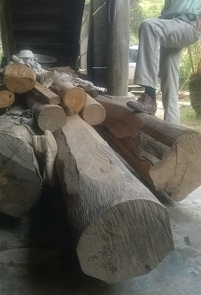

At this exploitation speed of about 7 tons per day, this middleman is collecting about 2,000 tons of wood size 15 cm and above every year.

Nam Son commune is of cluster 3. For a population of 5499 people for the demand of 22.51 kg of fuelwood per person per month, the total demand for the commune per year is 1,485 tons of wood per year for household cooking, in which 90% are of wood size less than 15cm. This means the amount of wood size more than 15 cm for residential demand is only 148 tons per year, compared to 2,000 tons of wood size 15 cm and above collected by the middleman to be sold to industrial plants. The consumption of residential demand is only 5-6% of valued wood of 15 cm and above.

**Discussion of local industrial plants’ fuel wood demand of Nghe An and Thanh Hoa**

Interview at the MDF plant (located in Nhu Xuan district, Thanh Hoa province) that the middleman in Nam Son commune mentioned shows that the plant purchase 200 tons of wood per day, in which 90% is for MDF materials, and 10% is for fuelwood for its boiler. That means every day the plant consumes of 20 tons of fuelwood. Most of the wood (material and fuel) are from Nghe An and from forest conversion activities as described by the middleman in Nam Son commune. The manager of the plant worries that in the next 2-3 years, this source of wood will run out and the plant will face difficulties in purchasing wood as the price of plantation wood (acacia) is 30% higher than the price of current wood purchased. When asking if the manager is interested in saving 10% of cost of fuelwood by improving operation to increase efficiency, the manager says that he is not interested because 10% of fuel cost take only a very small portion of the total product cost.

Below are some pictures of the wood at the MDF plant.

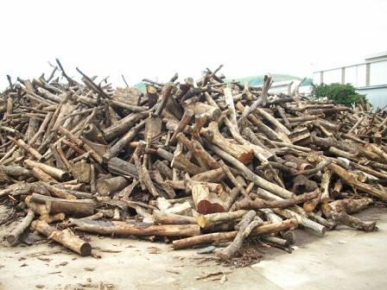

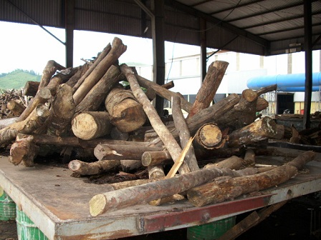

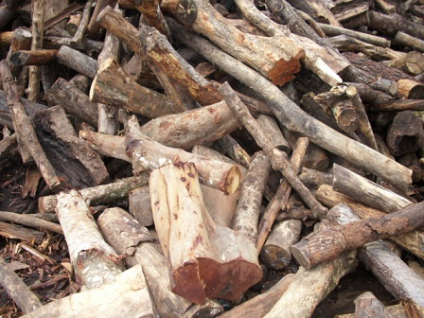

Other 2 visits was made to a tea plant in Thanh Chuong district and a tea plant in Anh Son of Nghe An. These districts are located further down to delta of Nghe An province.

For the tea plant in Thanh Chuong district, total installed capacity of this plant is 25 tons of fresh tea per day. At the moment the plant is operating at the capacity of 12-15 tons of fresh tea per day (4-5 tons of dry tea per day) and is consuming 29 – 35 tons of wood per day. This means that every ton of dry tea need 7,3 tons of fuelwood (natural wood). 3 years ago they used dust coal fired furnace to dry the tea. But since 2011 they switched to wood firing because it helped saving up to 30-35% of the cost. The wood they bought are from Laos and Ha Tinh province because the distance of transport from Laos and Ha Tinh are closer than from other area of Nghe An (within 50km).

According to the director of this plant, there are 6 other tea plants of the same size or bigger than this plant. They all used fuelwood for drying tea. It is therefore assumed that at least 200 tons of fuelwood are consumed per day at tea plants of Thanh Chuong district.

|  |  |
| --- | --- |
| E:\GFD\02 Ongoing projects\0193 SNV fuelwood baseline\Implementation\Field Trip\Anh\Anh report\WP_20140823_006.jpg | E:\GFD\02 Ongoing projects\0193 SNV fuelwood baseline\Implementation\Field Trip\Anh\Anh report\WP_20140823_003.jpg |

Other 2 visits was made to 2 paper mills, one is Song Lam paper mill in Hung Nguyen district of Nghe An province, and the other is Muc Son paper mill in Tho Xuan district of Thanh Hoa province. Both these two plants are using coal and dust coal for their boilers. According to the managers, they have tried to use fuelwood several years ago, but the cost of using fuelwood is higher than that of coal.

It is noted that Hung Nguyen district of Nghe An and Tho Xuan district of Thanh Hoa both belong to cluster 2 of which the characteristics are highly towards ‘delta’. Therefore it is assumed that fuelwood is not a popular energy source for delta area. Instead they use coal which is more traditional, easy to access, and price competitive.

**Discussion of a general picture of fuelwood consumption in Thanh Hoa and Nghe An**

From the survey it is found out that the fuelwood are only transported within the distance of about 50km from the forest source. Longer distance of transport will cost higher, and take more potential transport police punishment. Therefore there is not a further supply chain of fuelwood because of uncompetency in price.

Lack of detailed survey on local industrial plants’ demand for fuelwood leads to a less precise estimation of proportion of industrial consumption and residential consumption. However, there is a clear trend that more than 60% of valued natural wood (size 20cm and bigger) are consumed by the local industrial demand. This rate may increase even

## Value chain assessment in relationship to forest degradation and deforestation

Charcoal is not popularly used in the area of research. In fact, among 251 households surveyed and 6 plants visited, non of those use charcoal as a source of fuel. Therefore charcoal is not included in the survey and in the value chain assessment.

The below chart represent the value chain of fuelwood in Thanh Hoa and Nghe An

|  |  |  |  |  |
| --- | --- | --- | --- | --- |
| **Actor** | **Activity** | **Location** | **Income (VND/ ton)** | **Value (VND/ ton)** |
| Farmer/ Wood logger | Logging wood | Natural forest near truck road | 140,000 | 140,000 |
| Wood collector | Carry and upload wood to truck | Collection Site (truck road) | 150,000 | 290,000 |
| Middleman | Prepare transportation license, letter of origin | Commune Office | 180,000 | 470,000 |
| Transporter | Transport | Distance 50 km | 180,000 | 650,000 |
| Industrial Plant |  |  |  |  |

The value chain of fuelwood is as below:

The farmers are hired by the wood collector to log wood from the forest for a wage of 140,000 VND per ton. The wood collector upload the wood on a farm vehicle and carry to a truck road, where the truck is waiting. He then upload the wood on the truck and sell them to the middleman for 290,000 VND per ton. The middleman is responsible for preparing transport documents for the wood and get verified by the commune rangers. Then the middleman hire a transporter to sell the wood to the industrial plant for 650,000 VND per ton. The middleman pay the transporter for 180,000 VND per ton for 50km of transportation. He is making 180,000 VND per ton of wood.

If the natural forest is 2km from truck road, then the wage for the wood logger is only half, of 70,000 VND per ton of wood. The wage for carry wood for 2km from the forest to truck road is 70,000 VND.

There are no further chain outside of local industrial demand, no further commercial activities of transporting wood outside of the provinces.

***Discussion of forest degradation and deforestation***

While deforestation is not very obvious as natural forests are converting to plantation forest (so forest area is not decreased), it is clearly that forest degradation is under great pressure of fuel wood demand and land conversion.

Vast land conversion (from natural forests to plantation forests) in some specific areas of Nghe An is causing lose of rich and medium natural forest. This is to plant acarcia for paper materials, which has higher value than fuelwood.

Fuelwood consumption of both industrial sector and residential sector is also creating pressures on fuelwood supply. In which, consumption of industrical sector take a bigger proportion of demand (60%) and tend to increase, while consumption of residential sector take a smaller proportion of demand (40%) and tend to decrease.

# Recommendations

## Un urgent need for revision of land conversion in some specific area

The forest land conversion from natural forest to plantation forest to develop acarcia trees for paper materials needs to be revised carefully. While selling acarcia may lead to a direct increase in income of farmers and households as the price of acarcia is higher than the price of natural wood to be sold as fuelwood, a vast plan for this conversion may cause a serious and large scale of forest degradation.

It is recommended that forest inventory in Nghe An should be taken more precisely that will help categorizing natural forest more precisely and developing better conversion plan.

## Un urgent need for forest land administration in some specific area

In Tuong Duong district in Nghe An province, a serious cause of deforestation is that there is not a legal boundary to identify the location of cultivation area and forest area on administration map and on field. The cultivation and forest land certificate only indicate the area, but there is not a map to indicate the site that farmers can cultivate. This leads to the fact that every year households burn an area of forest for cultivation.

It is recommended that a budget should be allocated for mapping of cultivation land and forest land in some specific area of Nghe An, such as Tuong Duong district.

* Làm Rẫy hàng năm của dân trên đất rừng TN là nguyên nhân quan trọng mất làm mất RTN. Ở huyện Tương Dương, đất rẫy chỉ được xác định về diện tích trên sổ sách, mà không được xác định ranh giới cụ thể trên bản đồ lẫn trên thực địa. Hàng năm, mỗi thôn tự chọn cho mình một khu đất rừng có độ phì tốt cho Lúa hay Ngô, mà phần lớn là rừng tự nhiên nghèo. Mỗi hộ phát khoảng 1-2 ha tùy số khẩu. Năm sau, họ lại tìm khu đất rừng tự nhiên khác để phát rẫy mới. Điều đó khiến RTN mất liên tục và trên diện rộng. Chính quyền huyện và Kiểm lâm đều biết, song không can thiệp được, vì không có ranh giới pháp lý trên bản đồ. Hiện tại, đất rẫy được quy hoạch chung vào đất “sản xuất lâm nghiệp”. Nghĩa là rất mập mờ về pháp lý.

## Improved stoves

A program of improved stoves could be introduced selectedly to the households that raise pigs in a big quantity and that have to buy wood not collected for free such as in Xuan Cao commune of Thuong Xuan district, Thanh Hoa, and Hung Son, Duc Son commune of Anh Son district, Nghe An. To these households, saving wood is relating to saving costs. Therefore improved stoves program may have more opportunity for success.

Improved stoves could also be introduce to household that has supplement jobs such as alcohol cooking and taufu making.

This could lead to less demand for fuelwood.

## Stability of electricity supply

Access to a stable electricity supply may also encourage households to use alternative energy so that the demand on fuelwood may decrease.

In Ngoc Khe commune of Ngoc Lac district, Thanh Hoa, the commune officer said that due to electricity unstable, many electric rice cookers of households have broken, that lead them to go back to the traditional energy of fuelwood.

Therefore stable electricity supply could be considered to reduce pressures on fuewood demand.

## Training on natural forest management skills for households

About 90% of fuelwood consumed by households are of the size less than 15 cm. 70% of these are from natural forest. While it is not possible to stop this demand immediately, a training on natural forest management skills for households may improve the situation.

Natural forest being properly managed by cutting down small trees (size 15cm and less) will lead to a better development for valued tress (size 20cm and bigger) so the big valued tree can get mature and crown (khép tán). Under the crown of big and valued tree, other layers of forest may develop to increase biodiversity.

Therefore a training program should be conducted for households, so that help them to collect quality wood from natural forest, while also taking care for values trees in natural forest.

## Creation of fuelwood source

As the demand for fuelwood will not decrease significantly in coming years, a program of activities for planting fuelwood should be considered to create fuelwood for the future.

1. R. Johnson and D. Wichern (1992). *Applied Multivariate Statistical Methods*, Third Edition. Prentice Hall. [↑](#footnote-ref-1)